Model Optimization and Tuning Phase

Name | Nilofar Rafik Shaikh
Skillwallet ID | SWUID20260283092
Project Title | Uncovering the Hidden Treasures of the  Mushroom Kingdom A Classification Analysis
Maximum Marks | 10 Marks
Model | Tuned Hyperparameters
Model 1:  InceptionV3  (Baseline) | Learning Rate: We adjusted the learning rate, which controls how much the model learns from its mistakes. We tried different learning rates to find one that helps the model learn effectively without becoming unstable.  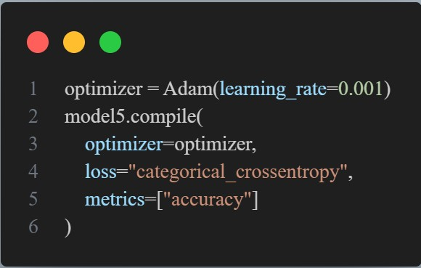

Model Optimization and Tuning Phase
The Model Optimization and Tuning Phase involves improving our neural network models to get the best results. This means adjusting the model's settings, comparing how well different settings work, and explaining why we chose our final model.
The neural network models were trained to classify mushroom images into the following three classes: Boletus, Lactarius, and Russula. The training dataset consisted of 911 labeled mushroom images across the three target classes. A separate dataset of 292 images was used for validation and final evaluation of the models.
Hyperparameter Tuning Documentation (8 Marks):

Batch Size: We changed the batch size, which is the number of images the model processes at once before updating its knowledge. We tested different batch sizes to balance speed and memory usage.
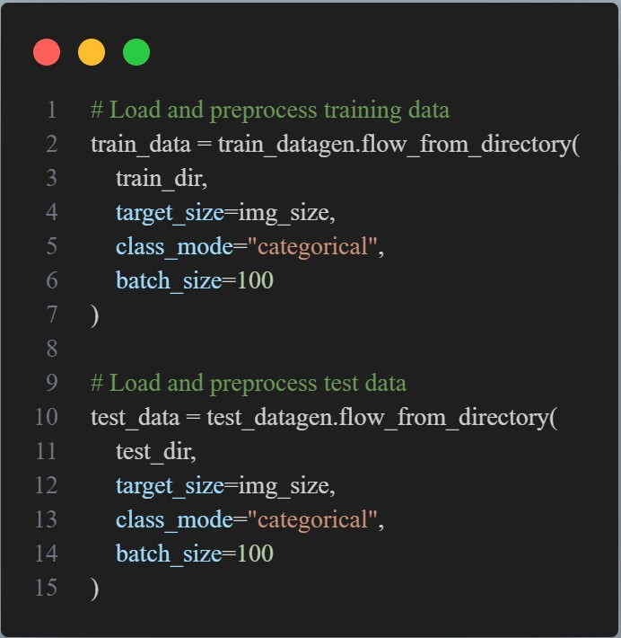
Model 2:  InceptionV3  (Optimized) | Learning Rate: We made finer adjustments to the learning rate, building on what we learned from Model 1, to see if we could improve performance further.  

Batch Size: We used the best batch size from Model 1.

Accuracy:
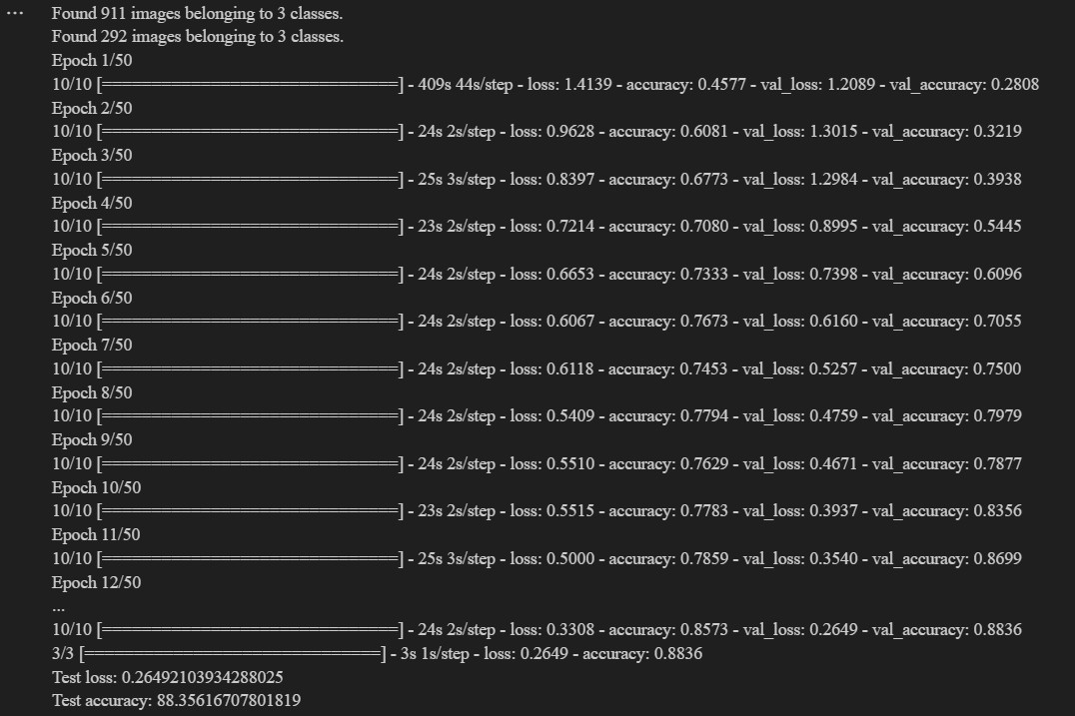

Final Model Selection Justification (2 Marks):
Final Model | Reasoning
Model 2:  InceptionV3  (Optimized) | We selected Model 2 as our final model because it demonstrated a significant improvement in validation accuracy compared to Model 1, achieving 88.36% compared to Model 1's best of 84.59%  The image provided shows the training output. We felt the higher accuracy was worth the extra training time. Model 2 also seemed to generalize better to new images.

